**1. Create Virtual Networks for IT and HR Departments**

**Steps:**

* **Create two virtual networks** in Azure, one for each department:
  + **IT Department VNET**:
    - Name: VNet-IT
    - Address Space: 10.0.0.0/16
    - Subnet for Linux VM: 10.0.1.0/24
    - Subnet for DNS Server: 10.0.2.0/24

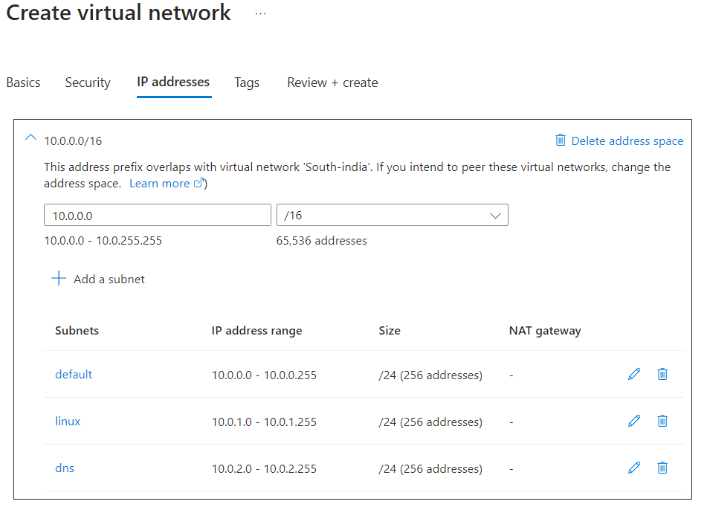

* + **HR Department VNET**:
    - Name: VNet-HR
    - Address Space: 10.1.0.0/16
    - Subnet for Web App: 10.1.1.0/24
    - Subnet for Linux VM: 10.1.2.0/24

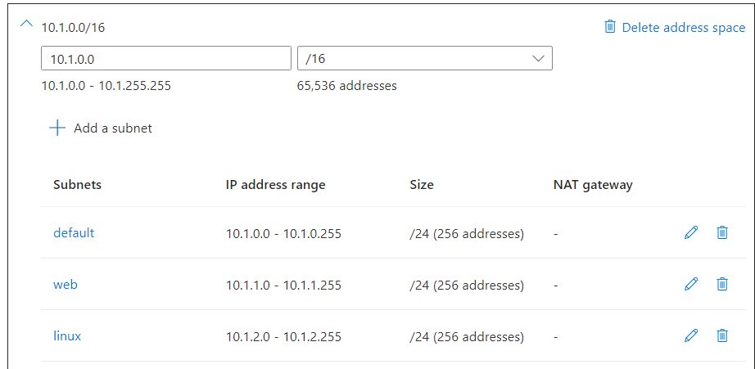

**Deploy Resources:**

* In **IT Department VNET**:
  + Deploy a **Linux VM**.
  + Deploy a **DNS Server** on another Linux VM in a separate.
* In **HR Department VNET**:
  + Deploy a **Linux VM**.
  + Deploy a **Web App** in the App Service for hosting the company's website.

**2. Establish Private Communication between IT and HR Departments**

**Method:**

* Use **VNET Peering** to enable communication between the virtual networks.
  + Peering between VNet-IT and VNet-HR.
  + Ensure **Allow Forwarded Traffic**, **Allow Gateway Transit**, and **Allow Virtual Network Access** are enabled for bidirectional communication.

**Steps:**

* In the Azure Portal:
  + Navigate to the **Virtual Network** for each department.
  + Set up **VNET Peering** between the two VNETs.
  + Configure the routing to allow communication between the subnets.
  + Confirm private IP address communication between VMs across the peered networks.

**3. Use Azure DNS for Domain Names**

**Steps:**

* Set up **Azure DNS Zone** to assign a domain name to the DNS server.
  + Create a new **DNS Zone** (e.g., xyzcorp.local).
  + Add **A records** for:
    - DNS Server VM (e.g., dns.xyzcorp.local -> Private IP of DNS server)
    - Web App in HR (e.g., webapp.xyzcorp.local -> Private IP of Web App)
  + Configure the **DNS Server** with the Azure DNS Zone.
  + Update the network settings of the virtual networks to use the **DNS Server** as the DNS resolver for both VNet-IT and VNet-HR.

**4. Ping the Private Address from the DNS Server to the Website**

**Steps:**

* From the **DNS Server VM** in the IT department:
  + Use nslookup to verify that the DNS resolution works for webapp.xyzcorp.local.
  + Use ping to test connectivity to the Web App's private IP address (or domain name).
  + Open a browser on the **DNS Server VM** and access the website using the assigned domain name (e.g., http://webapp.xyzcorp.local).

**Summary of Required Tasks:**

1. Create VNETs for IT and HR departments with appropriate subnets.
2. Deploy Linux VMs in both VNETs, along with a DNS server in the IT department and a web app in the HR department.
3. Establish private communication between the VMs by using VNET peering.
4. Set up Azure DNS to assign domain names to the DNS server and the web app.
5. Test communication by pinging and resolving DNS records to ensure the DNS server can reach the web app in the HR department.

This setup will enable private communication between the departments while maintaining secure and isolated networks.